Week 6 - Seminar Questions

- The two types of chi-squared test:

- are both for two variables
- are the "goodness of fit" and the "test of association".
- test for the individual significance of a variable
- Perform an ANOVA test

- A six-sided die is thrown a number of times, and the results are in the table below.

Face showing: 1 2 3 4 5 6
Frequency: 73 74 43 63 42 90

What frequency would we expect to see for each face were it a fair die?

- A national vote has 28% of the voters for a proposal, and the remainder against. Locally, the 1,508 voters had 614 of them vote for it, and the remainder against. What is the test statistic for the goodness of fit chi-squared test?

- A test of association chi-squared test on data formed in 4 rows by 3 columns takes its critical value from which row of the table?

- A researcher is investigating an association between Age and Preferred Music. Their sample results are given below:

Pop Metal Classical
Young 37 43 46
Middle-Aged 13 48 10
Elderly 26 21 38

If these two variables were independent, what would the researcher expect to have in the Metal and Young entry?

- A researcher is investigating how drink preferences change with age. Their sample results are given in the table below:

Tea Coffee
Younger 39 22
Older 19 17

What is the test statistic to measure the association between Age and Drink Preference?

- Which of the following is a correct interpretation of the following SPSS output?

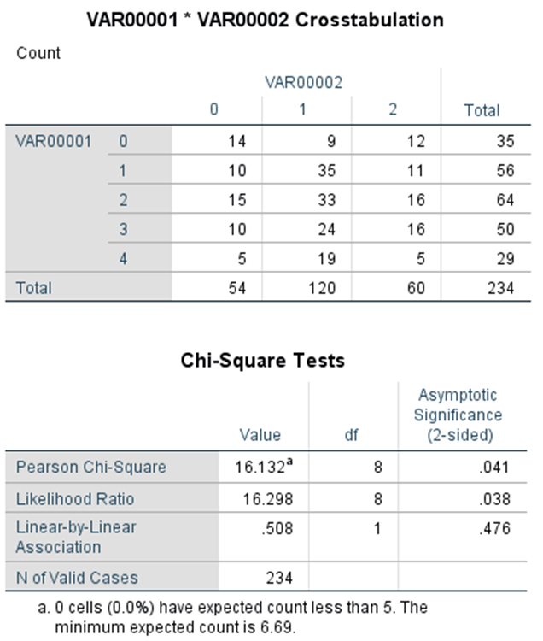

- The Expected Counts show what would be the case if the rows
were double the columns.

- A one-tailed p-value of 0.041 indicates we should reject the null
hypothesis and conclude that there is significant association between
the two variables.

- 0% of cells having expected count less than 5 means the test is invalid.

- Because the test statistic is greater than the df, we should reject the
null hypothesis.

